AATC_CryptoBeta
Introduction
This module contains the functions required for the use of the RSA certificate system used to validate a server and prevent a Man in the Middle attack. The system uses chains of certificates as well as domain name lookup to attempt to verify if the server is the server the user actually wants to connect to. RSA is a currently viewed as secure public key cryptography scheme which relies on the inherent difficulty of factorisation in order to maintain security. The RSA key pair consisits of a public and a private key, material encrypted with one cannot be decrypted with the same key but the other key can decrypt it. As both keys can be used to encrypt and decrypt the system can be used for both encryption and signing of data. Signing functions by distributing the public key and encrypting a value with the private key, anyone with the public key can decrypt the message but cannot forge this by encrypting an impostor message as only the person with the private key can correctly sign the message. This allows the client to verify who the person who signed the certificate was. As the certificate signed by a trusted entity / root certificate authority a client can verify that the certificate is genuine or not, preventing an middle man changing or reading the encrypted before the client or server recieves them in a Man in the Middle attack.

The certificates used have a general pattern:
Name → The string name of the owner. This should be the domain name registered to the IP of the server to domain name verification.
Issuer → The name of the entity who signed the certificate.
NotBefore → The time before which the certificate is not valid.
NotAfter → The time after which the certificate is not valid.
Public Key → The stored private key beloning to the certificate owner.
Signature → The signed hash of the other fields of the certificate.

Import
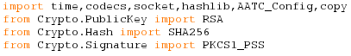
The time module is required to ensure a certificate is in a valid time bracket. The codec module is required to convert some datatypes so they may be accepted by other functions. The socket module is required for hostname verification. Hashlib is required for various hashing functions. AATC_Config is required in order to load the certificate limits and other constants. Copy is required to prevent alterations to the certificate chain.

The RSA module is required to generate RSA keys and to make RSA key objects. SHA256 is required for the hashing function, a seperate version of SHA256 compared to that provided by hashlib is needed as the signing function requires a crypto.hash.SHA256 object rather than a hash result. The PKCS1_PSS module is used to sign and verify the certificates.

Certificate functions
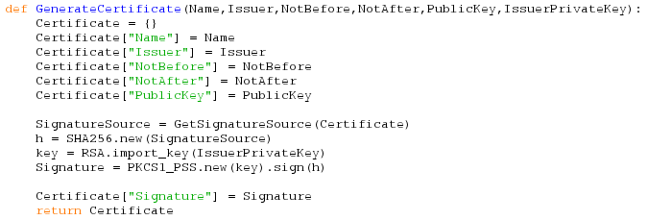
The generate certificate function is used to generate new certificates i.e. when a new server is created. The function simplifies the prodecure by returning the build certificates using the given parameters in a single call. The parameters required for the creation of the certificate are name, issuer, not before, not after , public key and the Issuer's private key. A new dictionary is created for the certificate , the relevant parameters then are stored in the certificate dictionary. The signature source , the string components of the certificate in a single string, is obtained. This source is placed into a SHA256 object and a RSA key object is created using the issuers public key. This key is then used to sign the SHA256 hash, the result being added as the signature of the certificate at the end. Lastly the certificate is returned.

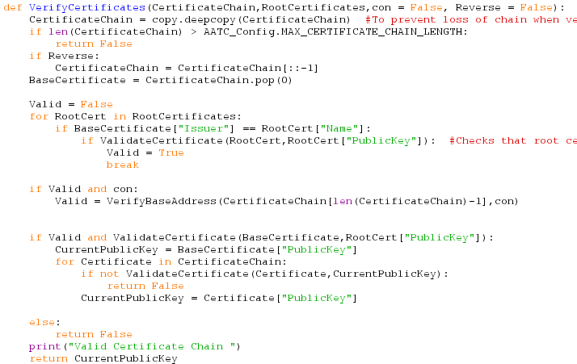
The verify certificates function is used to verify if a certificate chain is valid or not, returning the public key of the server if it is valid and False if not. The function takes 2 parameters and 2 optional parameters. The CertificateChain is a list of certificates, starting with the highest level certificate and ending with the server certificate. RootCertificates contains a list of trusted certificates, each signed by themselves ( therefore can be verified using itself as a source). Con can contain a connection object to the server, used to check if the domain name for the IP address connected to is the same as the name on the certificate. Reverse is used to reverse the certificate chain if it is ordered the incorrect way round.

First the function uses deepcopy to create a clone of the certificate chain, otherwise the chain would be altered by the function, leading to adverse effects as the chain list is a mutable data structure and components of the list are being removed, otherwise leading to the chain being emptied unexpectedly. Then the length of the certificate is compared to that of the maximum allowed length, if it is too long false is returned. If the reverse flag is set the chain is reversed.
The base certificate is removed from the chain, this is the certificate which is either a root certificate or a certificate signed by a root private key.
Valid is set to false in assumption that the item is invalid. Then each root certificate is checked against the issuer of the base certificate, if they match the root certificate is verified , if the root certificate is valid the valid flag is set to true and the loop is broken.
Should both the root certificate be valid as well as the connection object be present hostname verification will take place. For this process the last certificate of the chain (the server certificate) is passed to the hostname vertification function as well as the connection object. This function returns True or False depending on if the hostname was valid, the result being stored in the Valid variable.
Should the Valid variable now still be True and the base certificate itself be valid then the rest of the chain is validated. The base certificate public key is set to the current public key the for loop checks that each of the certificates in the chain is valid and signed by the previous certificates public key, should this not be the case the function returns false, and then setting the current public key to the current certificates public key.
Should either the base certificate or the valid variable not be true then the function returns false.
Should all of these checks suceed then the public key of the last/server certificate is returned.

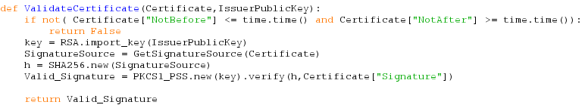
Validate certificate is used to verify a single certificate based on it's allowed time frame and it's signature. The function takes a dictionary Certificate and a byte string issuer public key. First the function checks that the time frame which the certificate is allowed via the NotBefore and NotAfter values is ok, should both be true the program continues, otherwise the function returns false.
The function also verifies that the signature is valid by creating an RSA key object, obtaining the SignatureSource of the certificate, creating a SHA256 object of this SignatureSource and passing this to the verify function of the PKCS1_PSS object. This PKCS1_PSS object returns True or False depending on if the signature is valid or not, therefore this value is returned.

The GetSignatureSource method is used to easily produce a small signature source text from the certificate itself. As RSA encryption cannot encrypt texts longer than the bit length the certificate must be made smaller to fit, the public key being the largest components. Therefore the program obtains a single string with each component of the certificate and the SHA256 hash of the public key in the hexadecimal format. This string is converted into a byte string and returned so it may be used in a separate hashing function.

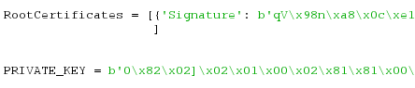
RootCertificates and PRIVATE_KEY are test variables, used to test verification functions and produce test chains. They are not needed but are convinient for testing purposes such as verification speed.

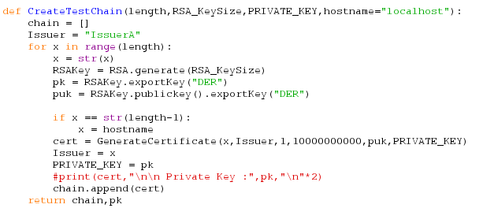
The CreateTestChain function is used to create test certificate chains only. The function takes 3 parameters and one optional parameter. The length controls the length of the chain, RSA_KeySize controls the RSA key size, PRIVATE_KEY is the private key used to sign the first certificate and hostname is the name given the the server certificate.
An empty chain list is initialised and the Issuer is set to “IssuerA” , the name of the certificate to which the private key belongs. The program then loops around length number of times , setting the current issuer name x to the string version of the current iteration. A new RSA key pair is generated and the public key and private key. If the x value is the last iteration x is set to the hostname. Then a certificate is generated using the current name, issuer , public and private key with default valid times of 1 → 10000000000000. The current x value becomes the new issuer (the current certificate is the issuer of the next certificate) and the private key of the current certificate becomes the new issuer private key. Finally the certificate is appended onto the chain. Once this process is complete the chain is returned as well as the private key of the server certificate, the private keys of all other certificates are discarded.

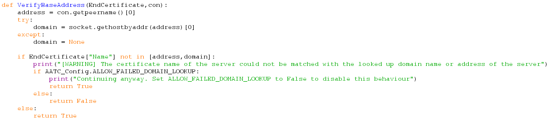
The verify base address function is used to check if a certificate name matches with the domain name received for the IP address which the connection object is connected to. This prevents a valid server certificate being presented by an attacker in a MiTM attack.. The function takes two arguments, EndCertificate a dictionary certificate and con, a connection object. The program obtains the IP address the connection object is connected to and attemptes to obtain the domain for this address, should this fail the domain defaults to None. If the certificate name matches either the address connected to or the domain name then the program returns True, if not a warning message is displayed that the program cannot verify this is the correct server certificate. If the config file parameter ALLOW_FAILED_DOMAIN_LOOKUP is set to True the program will return True , allowing the program to accept the certificate. Otherwise False is returned and the certificate is seen as invalid.

Verify_Certificates Pseudocode:
